****US BEVERAGE SALES ANALYSIS REPORT.****

****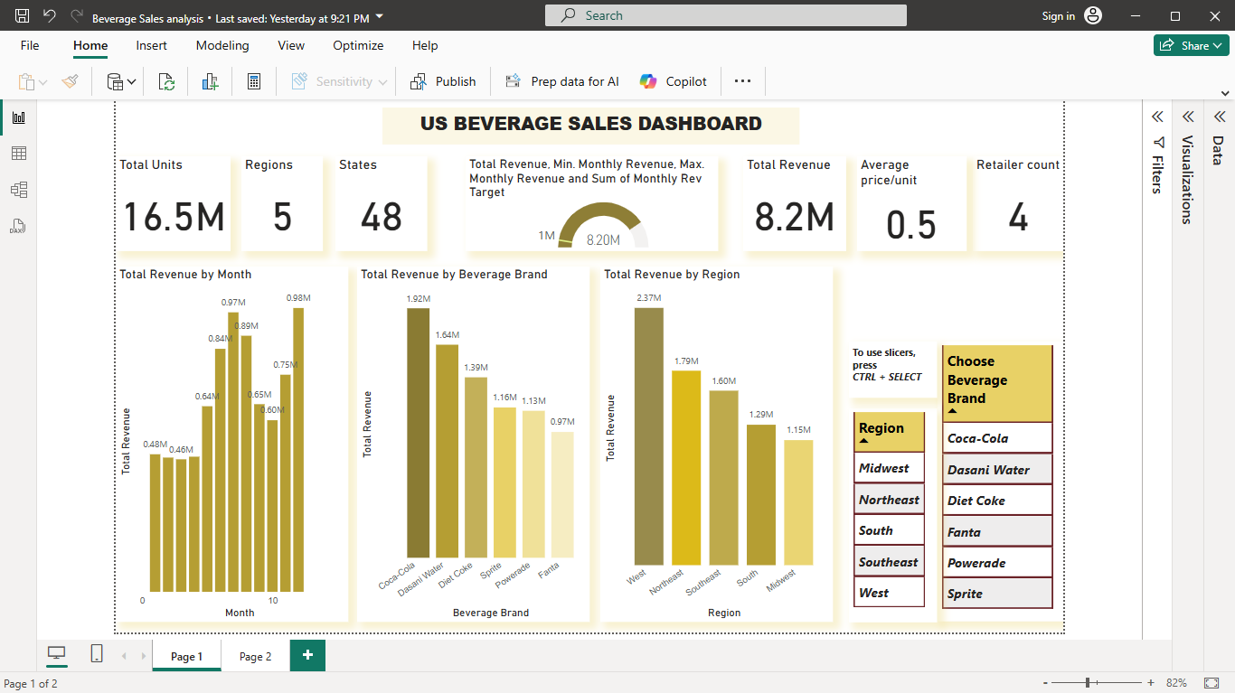****

****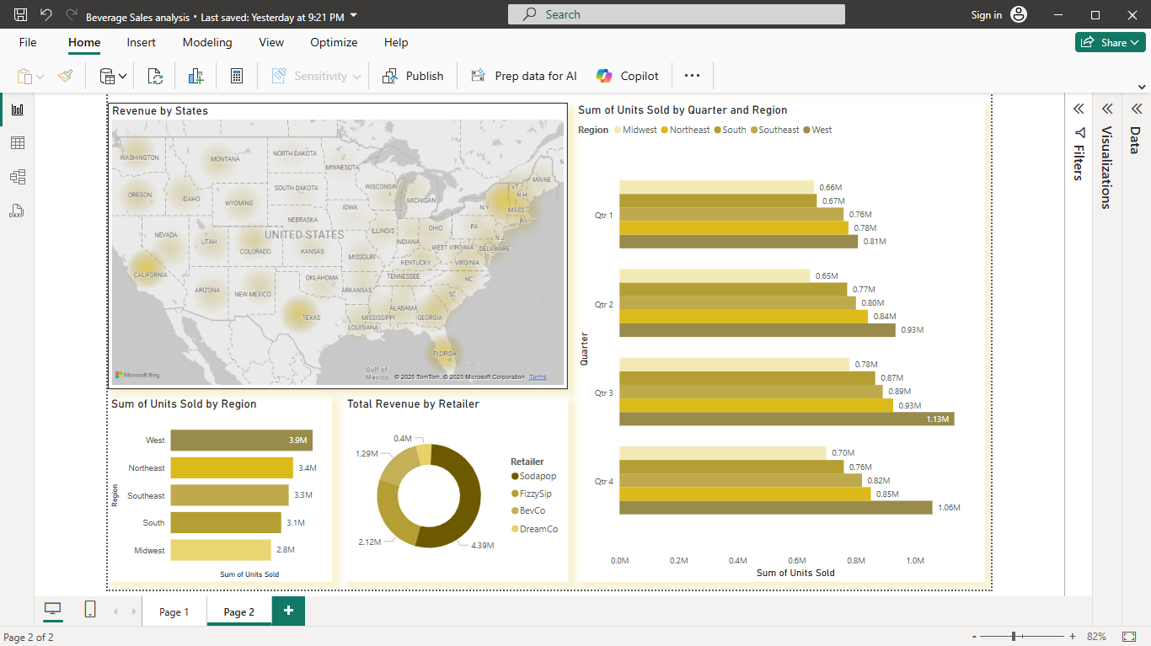****

***Dashboard of US Beverage sales analysis.***

**The analysis of the US beverage sales file has shown us some key insights into the sales of beverages.**

**Key Findings:**

1. **High-level Metrics:**

* **Total Units Sold: Over 16 million units, a strong volume indicator.**
* **Regions Covered:** 5 regions, showing broad market coverage in 48 states of the US, suggesting a decent retail network.
* Total Revenue: $[8.2](C:/Users/EMMANUEL%20FAGBEMI/Desktop/tel:8.2) million, which, when compared with units sold, gives an average price/unit of $[0.48](C:/Users/EMMANUEL%20FAGBEMI/Desktop/tel:0.48).
* Retailer Count: 4 major retailers, indicating sales are concentrated among a few key partners.

1. Trends & Breakdown:

* Monthly Revenue: There is a clear upward trend in revenue by month, peaking in the last month shown (over $[2.5](C:/Users/EMMANUEL%20FAGBEMI/Desktop/tel:2.5)M), which may indicate seasonality, promotions, or market growth.
* Beverage Brand Performance: Coca-Cola leads in total revenue among brands, followed by Dasani Water and Diet Coke. Sprite is the lowest among those listed, suggesting potential for growth or under-performance which needs to be checked urgently.

1. Regional Analysis: The dashboard allows filtering by region and beverage brand, which is useful for identifying regional strengths and brand-specific trends.

**The West region is the best performing region with 2.4M revenue generated and the Midwest region with 1.15M. There should be a sales promotion or a retailer swap in the Midwest region to promote sales.**

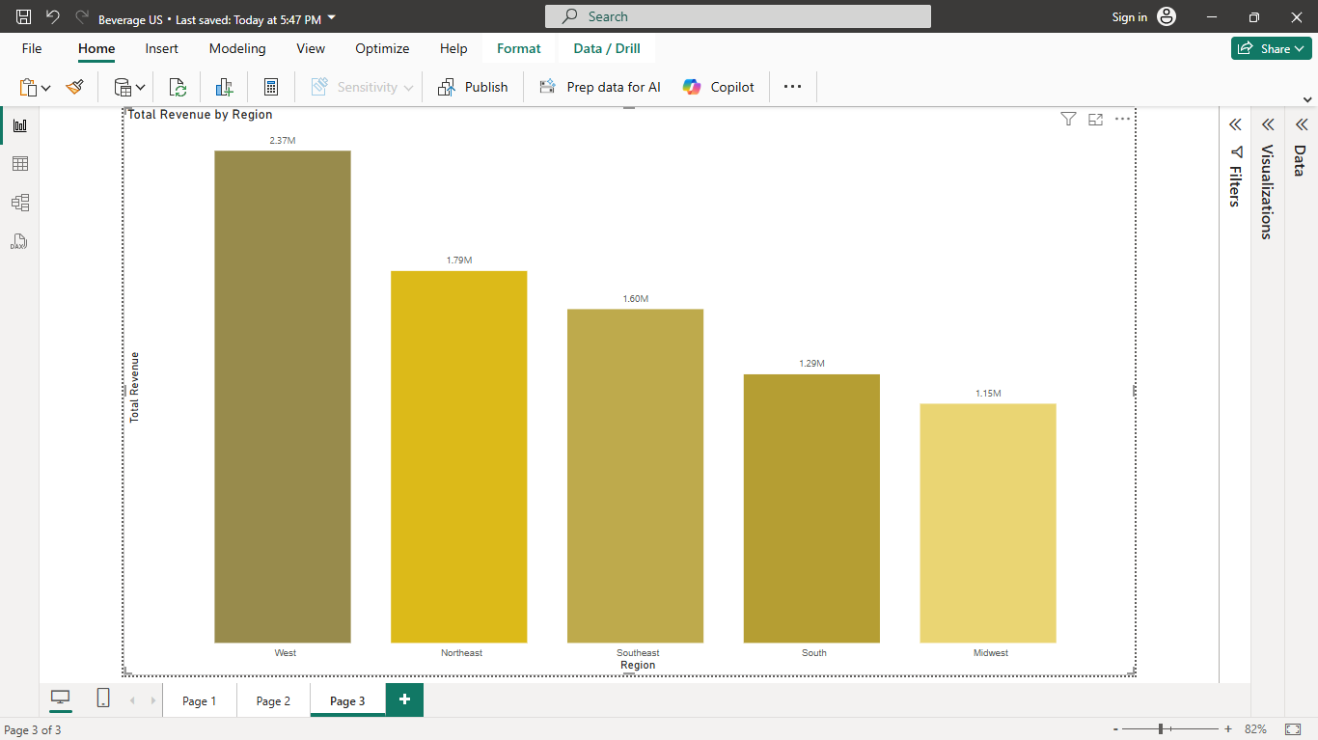

***Total Revenue by Region.***

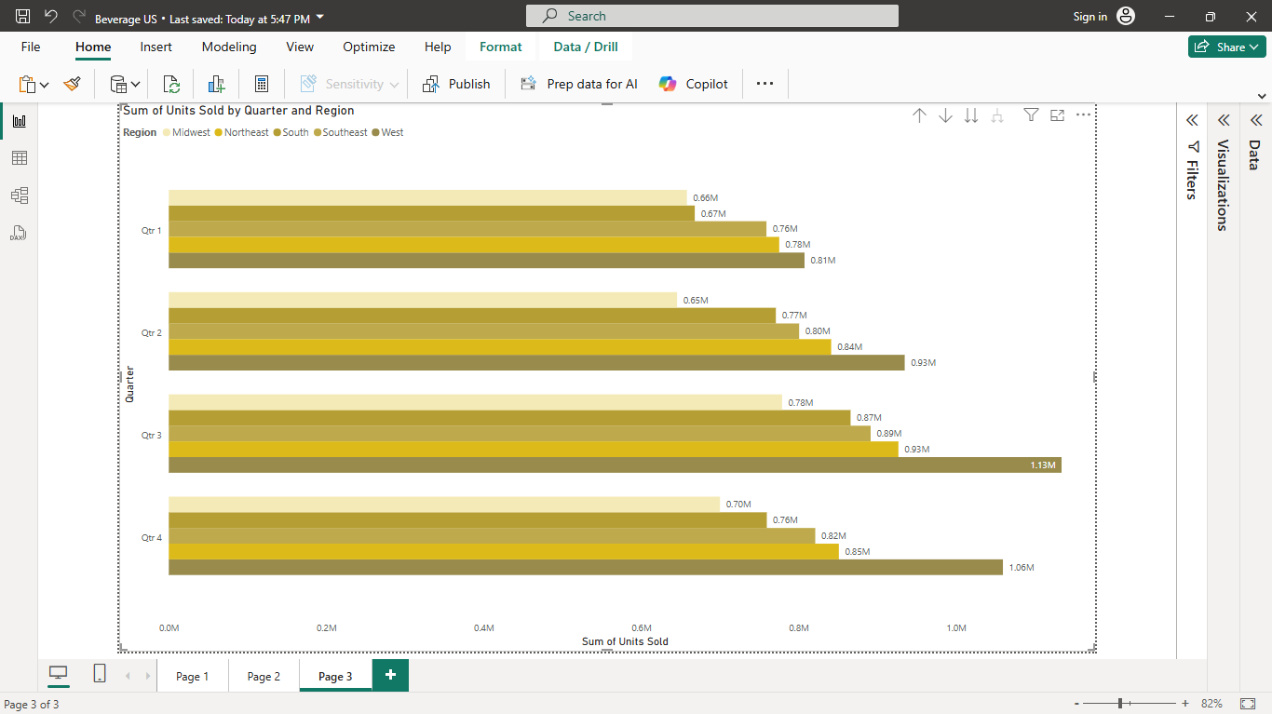

***Sum of units sold by Quarter and Revenue.***

1. Quarterly Performance: This chart compares the sum of units sold across different quarters for each region. Each region has four bars, showing quarterly performance side-by-side.
   * 1. Regional Leaders:   
           - The West region consistently outperforms other regions in every quarter, with units sold exceeding 3M in some quarters.  
           - The Midwest region has the lowest sales across all quarters, with values below 1M units sold per quarter.
     2. Quarterly Trends:   
           - Most regions show a relatively stable trend in units sold across the quarters, with some minor fluctuations.  
           - There are no dramatic spikes or drops, suggesting steady sales performance throughout the year.
     3. Performance Gaps:   
           - There is a clear gap between the top-performing and bottom-performing regions, indicating potential for targeted strategies in lower-performing regions for instance regional targeted promotions.

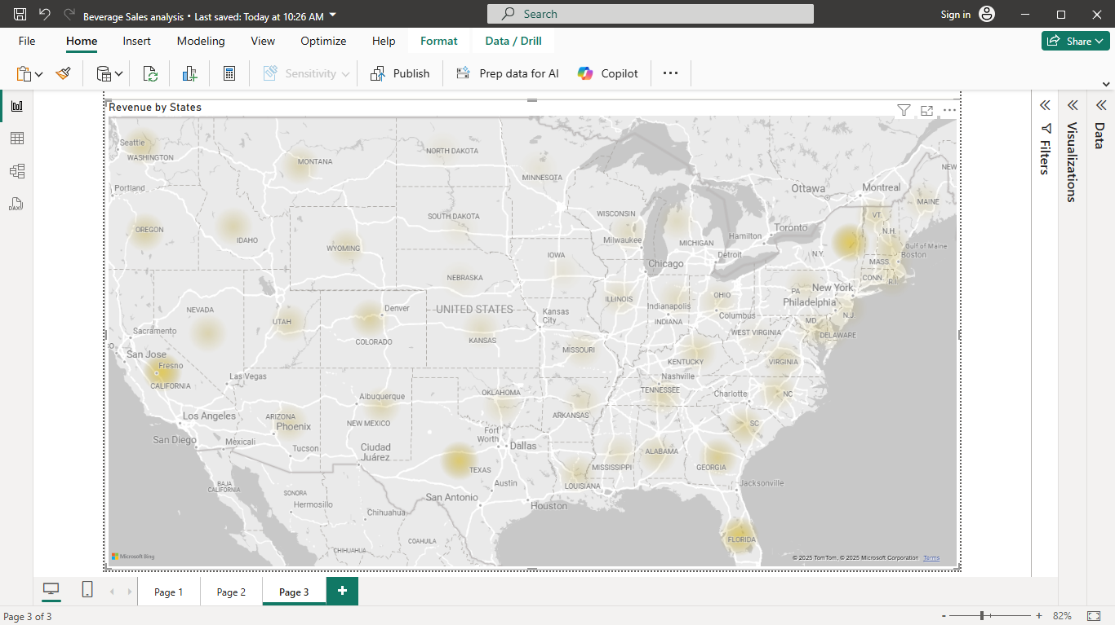

*Map of the US showing heat-map of Revenue by States*

* + 1. States:

**- Proper management/monitoring should be carried out with each state, because their performance directly affects regional sales performance and results.**